Eric McPherson
https://ericmcpherson.bandcamp.com/album/double-bass-quartet-live

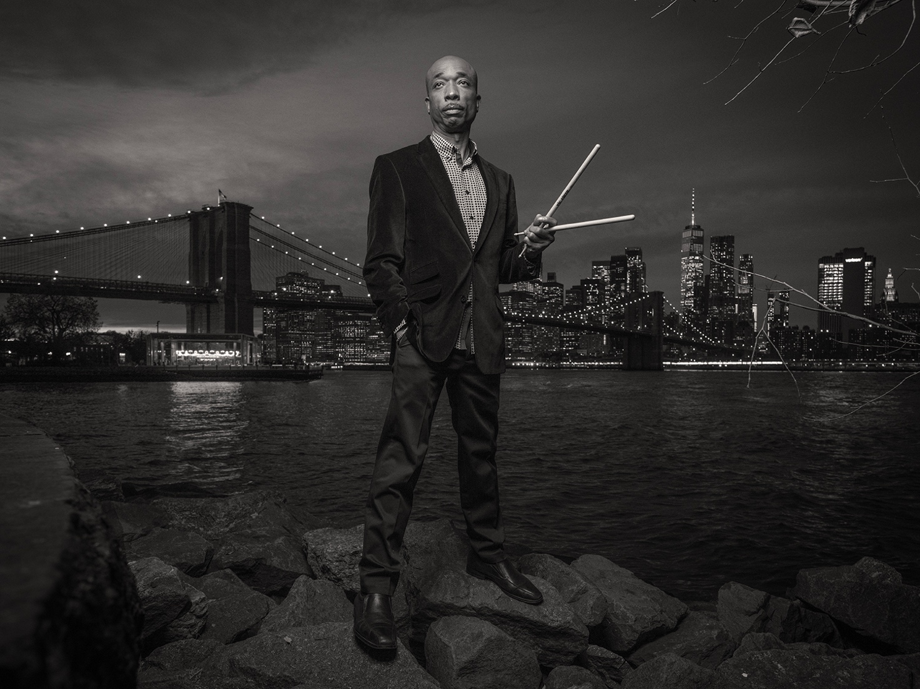

Chien Chien Lu
https://chienchienlu.bandcamp.com/album/built-in-system-2



Nasheet Waits
https://nasheetwaits.bandcamp.com/album/new-york-love-letter-bittersweet

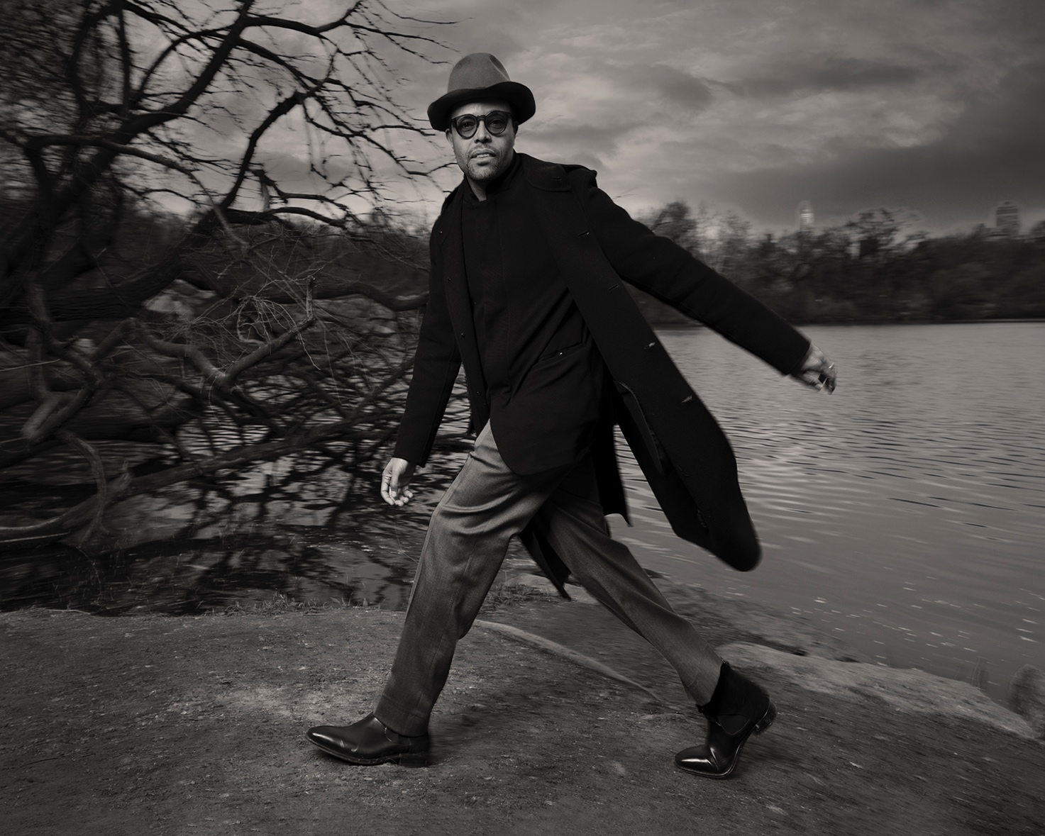

Michael Thomas
https://michaelthomasjazz.bandcamp.com/album/event-horizon

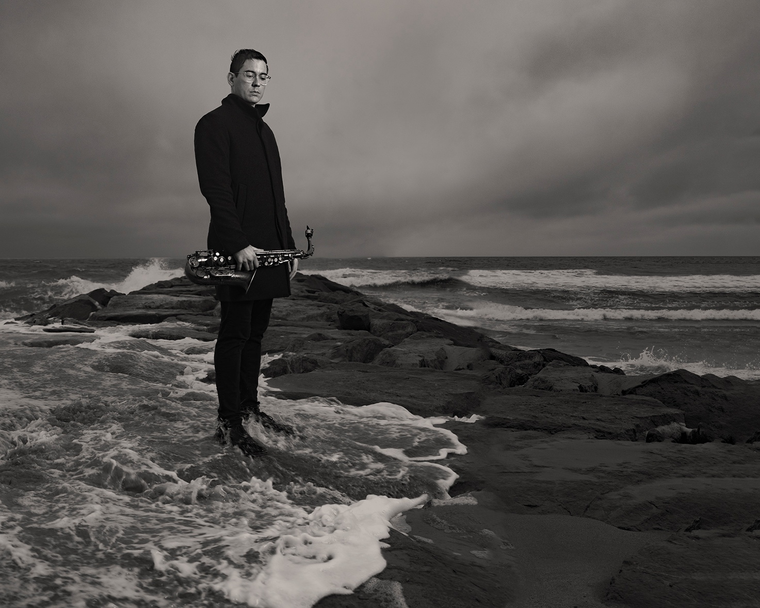

Eric Alexander
https://ericalexander1.bandcamp.com/album/leap-of-faith
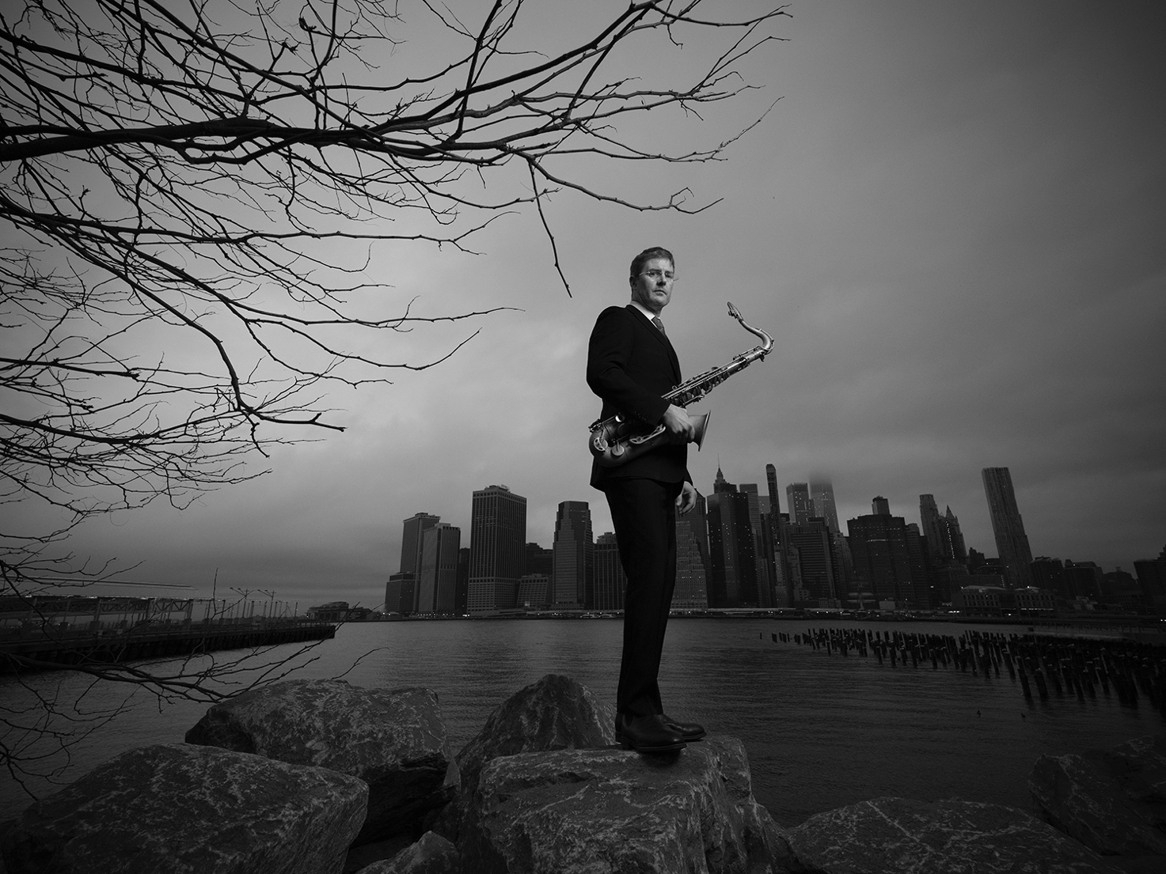

Johnathan Blake
https://johnathanblake1.bandcamp.com/album/trion
