Giant Step Arts presents: Live From Brooklyn

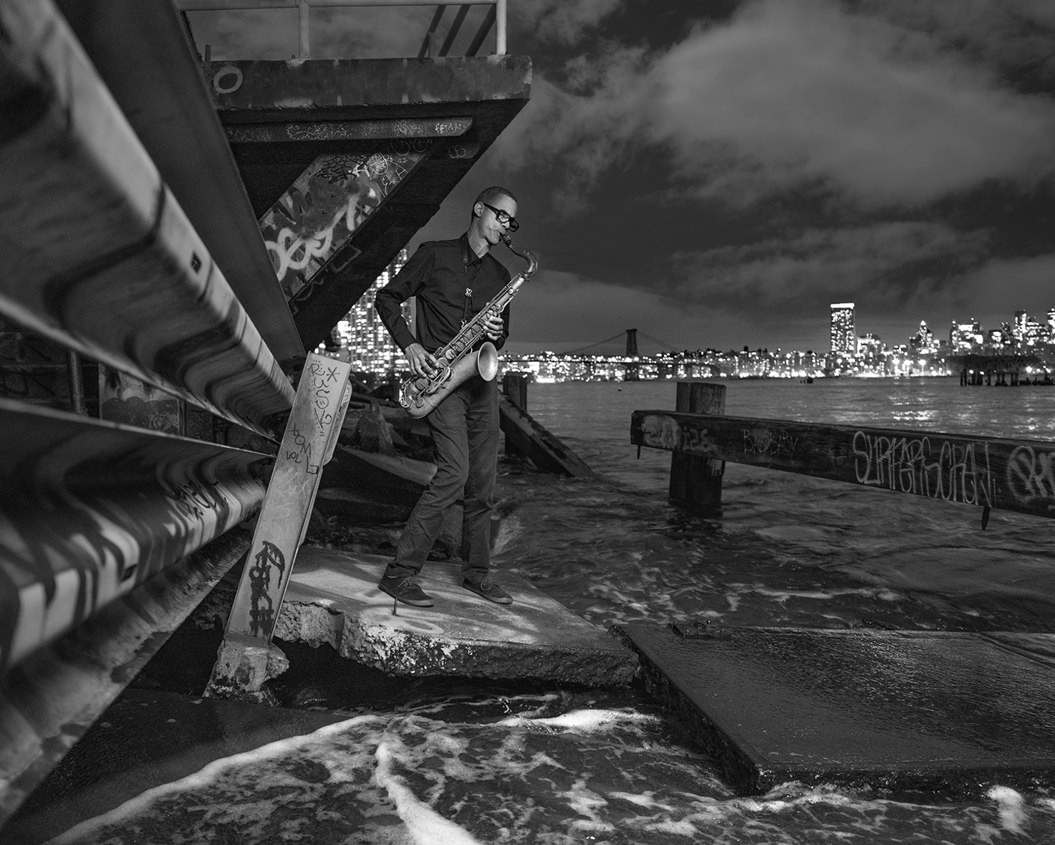

Photography, Jimmy & Dena Katz with Carl Chisolm

1)
The Phoenix - The Fencer (by Joe Martin; 2026 release)
(Marcus Gilmore, Joe Martin, Mark Turner)
Recorded Live at Ornithology in Brooklyn by Jimmy Katz & James Kogan.
Mixed and Mastered by Jimmy Katz with Dave Darlington.
Photography, Jimmy & Dena Katz

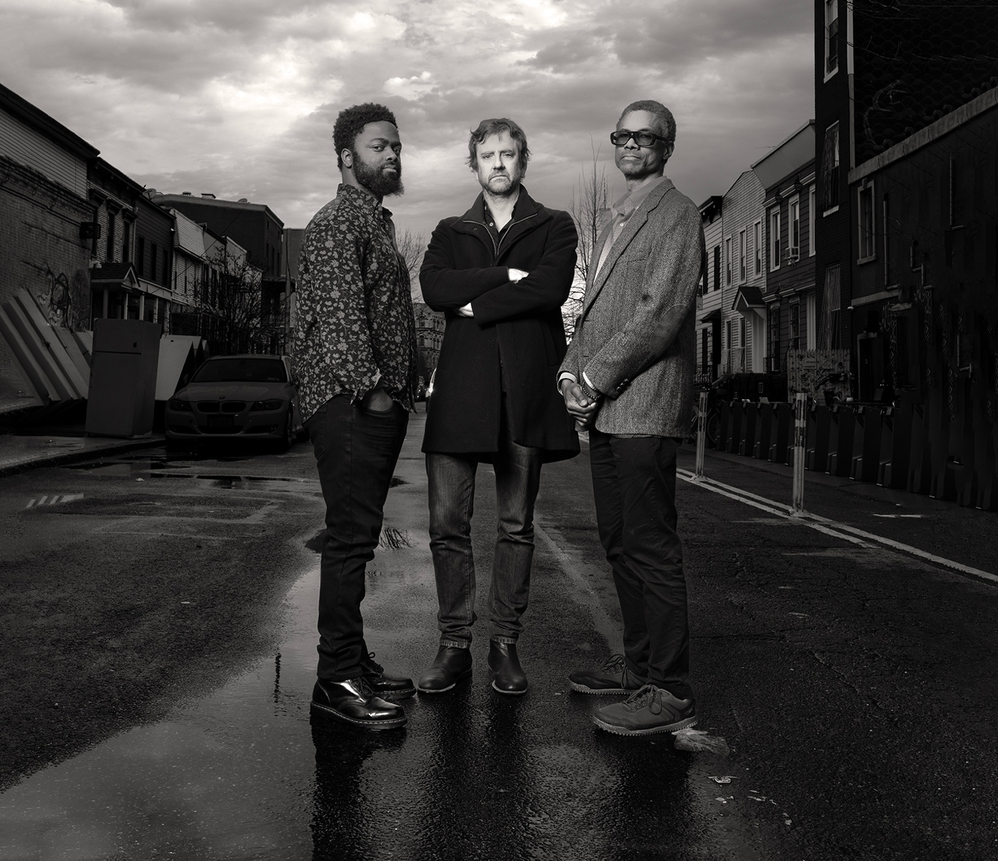

2)
Jason Palmer - Detroit (by Jason Palmer; 2026 release)
(Jason Palmer, Mark Turner, Kim Cass & Marcus Gilmore)
Recorded Live at Ornithology in Brooklyn by Jimmy Katz & James Kogan.
Mixed and Mastered by Jimmy Katz with Dave Darlington.
Photography, Jimmy & Dena Katz

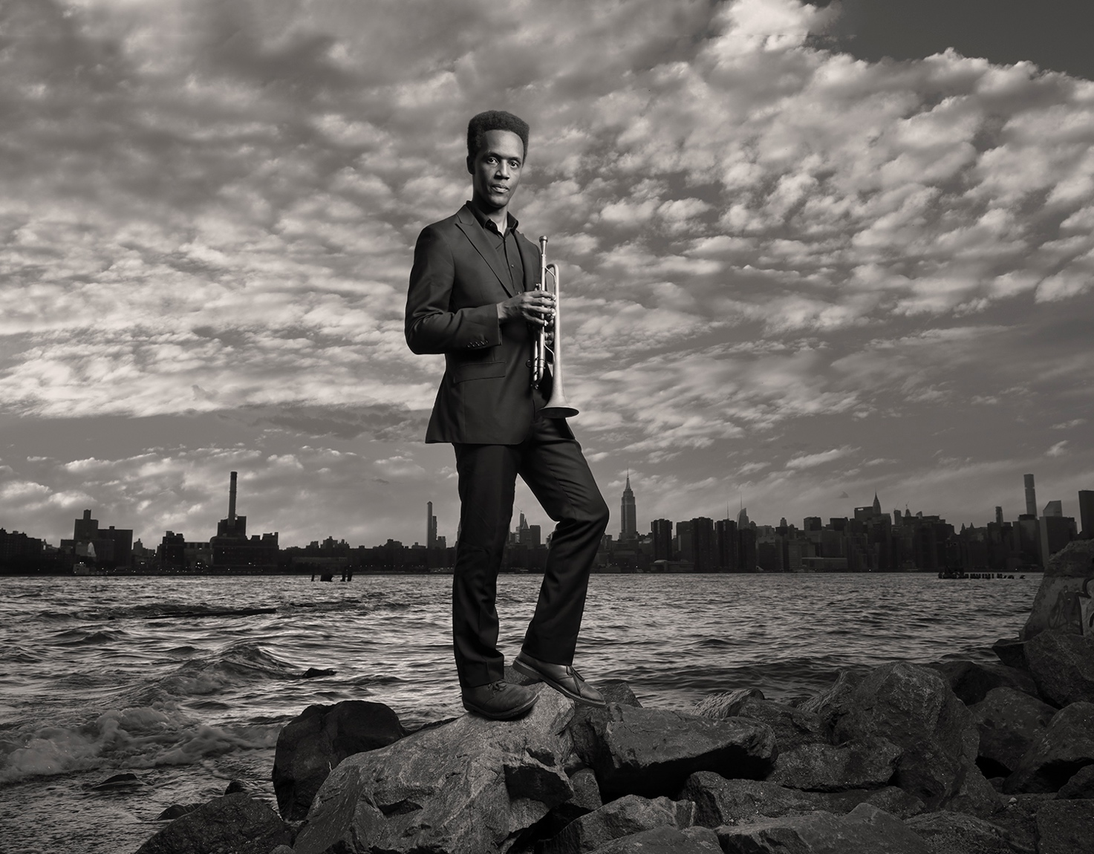

3)
The Spiral - #23 (by Lage Lund, 2026 release)
(Obed Calvaire, Lage Lund, David Sánchez, Matt Penman)
Recorded Live at Ornithology in Brooklyn by Jimmy Katz & James Kogan.
Mixed and Mastered by Jimmy Katz with Dave Darlington.
Photography, Jimmy & Dena Katz

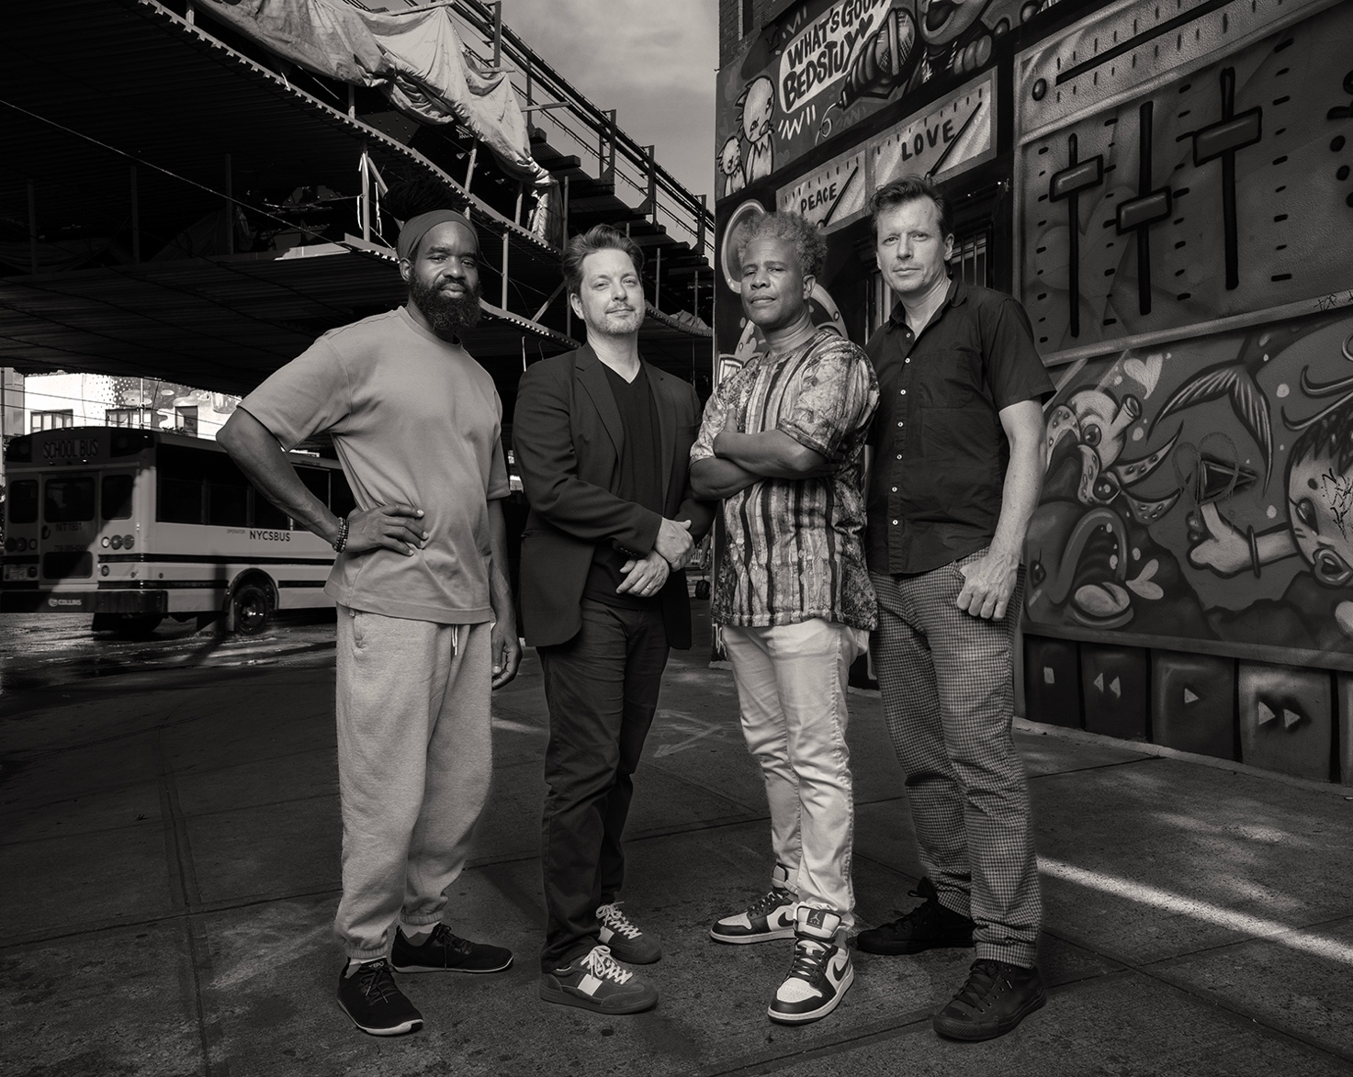

4)
The Fury - #21 (by Lage Lund, 2027 release)
(Mark Turner, Lage Lund, Matt Brewer, Tyshawn Sorey)
Recorded Live at Ornithology in Brooklyn by Jimmy Katz & James Kogan.
Mixed and Mastered by Jimmy Katz with Dave Darlington.
Photography, Jimmy & Dena Katz

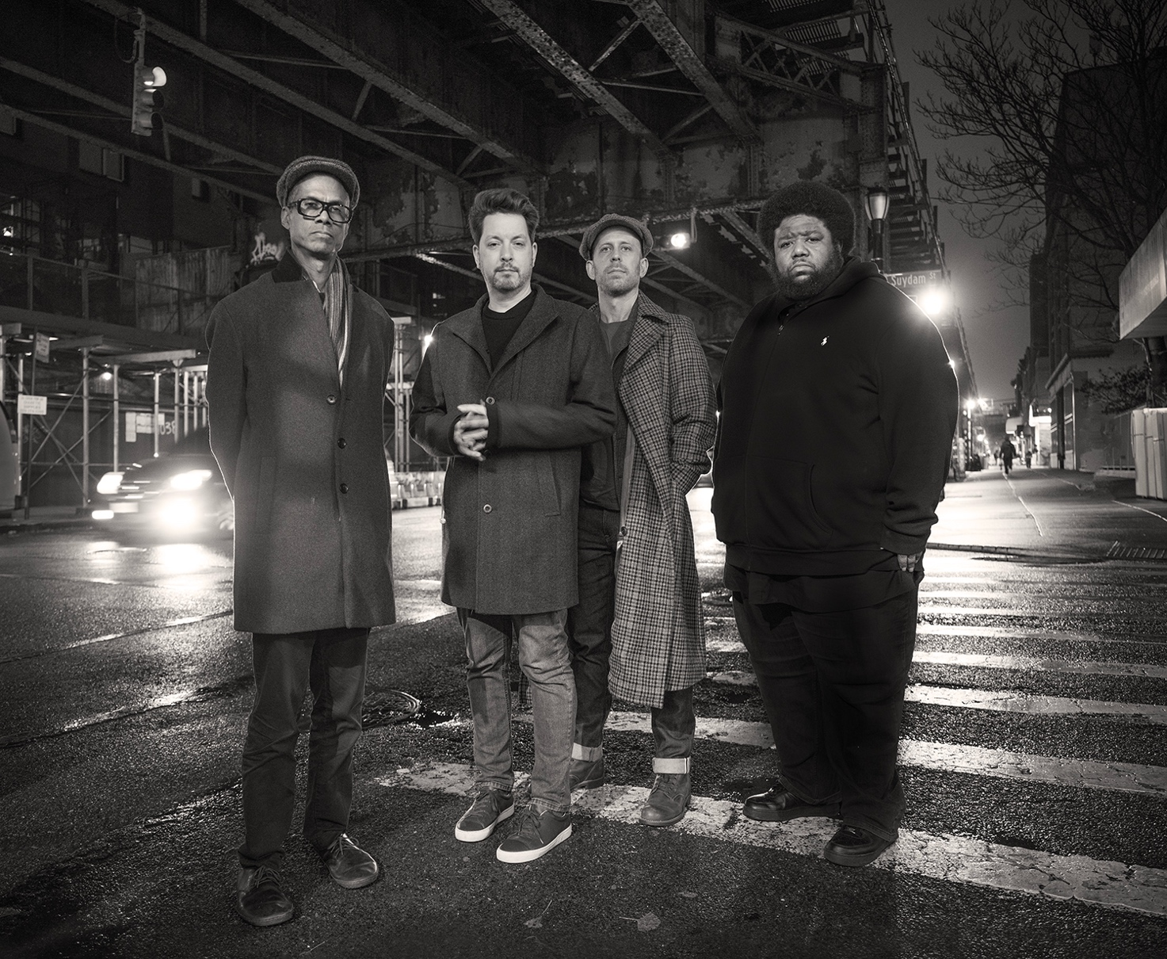

5)
Neta Raanan - Violet (by Neta Raanan “Unforeseen Blossom”)
(Joel Ross, Simón Willson, Kayvon Gordon)
Recorded Live at Bar Bayeux in Brooklyn by Jimmy Katz & James Kogan
Mixed & Mastered by Jimmy Katz with Dave Darlington
Photography Jimmy & Dena Katz
https://netaraanan.bandcamp.com/album/unforeseen-blossom

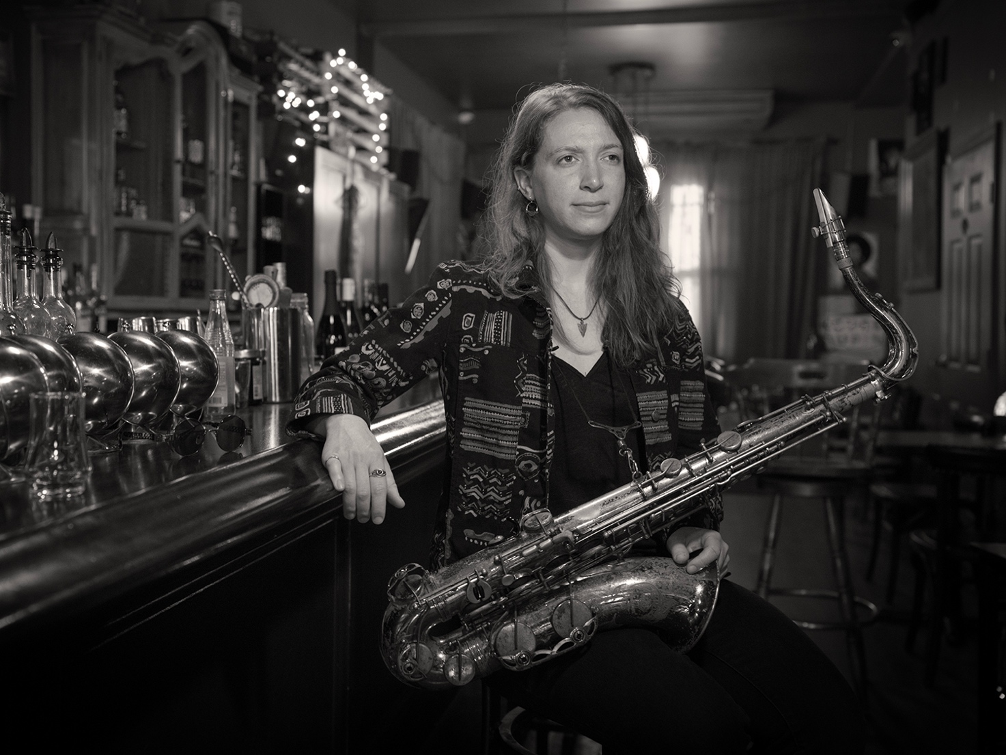

6)
Dave Adewumi - The Flame Beneath the Silence (by D. Adewumi, “The Flame Beneath the Silence”)
(Joel Ross, Linda May Han Oh, Marcus Gilmore)
Recorded Live at Ornithology in Brooklyn by Jimmy Katz & James Kogan
Mixed & Mastered by Jimmy Katz with Dave Darlington
Photography Jimmy & Dena Katz with Carl Chisolm
https://daveadewumimusic.bandcamp.com/album/flame-beneath-the-silence

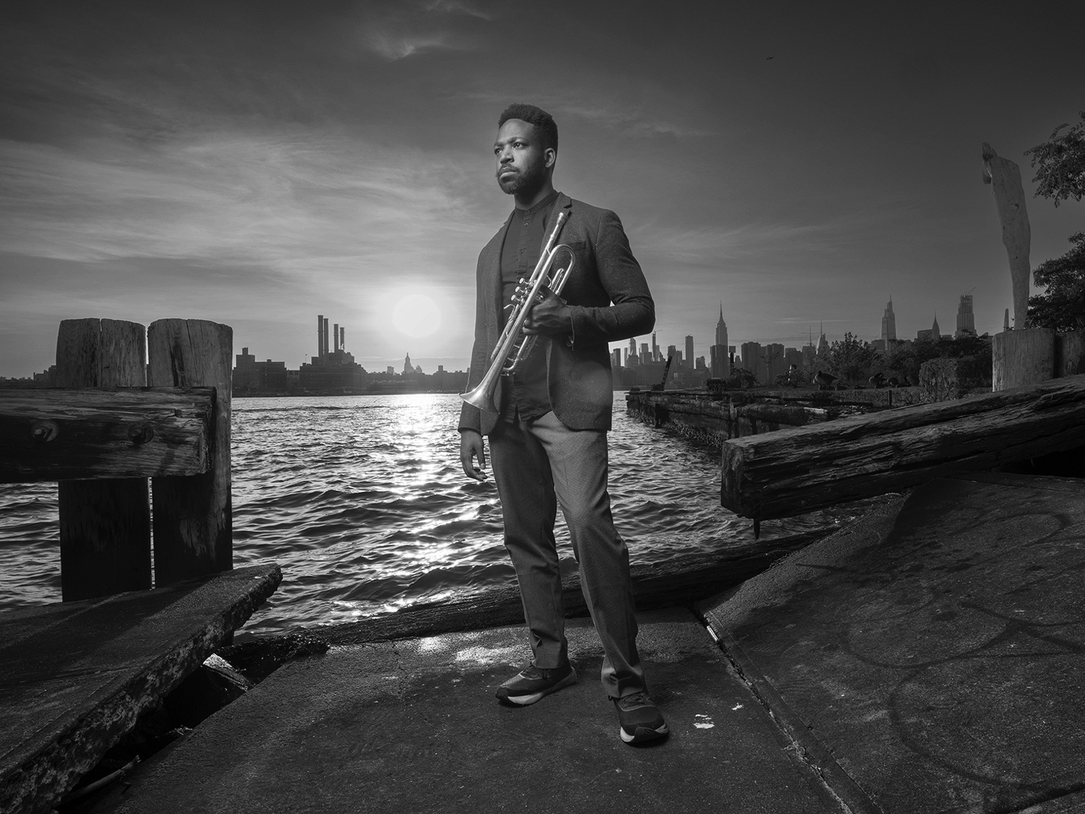

7)
Rico Jones - The Voice of God Shines Brightly on My Heart (by Rico Jones “Bloodlines”)
(Max Light, Joe Martin, Nasheet Waits)
Recorded Live at Ornithology in Brooklyn by Jimmy Katz & James Kogan
Mixed & Mastered by Jimmy Katz with Dave Darlington
Photography Jimmy & Dena Katz with Carl Chisolm
https://ricojonesjazz.bandcamp.com/album/bloodlines

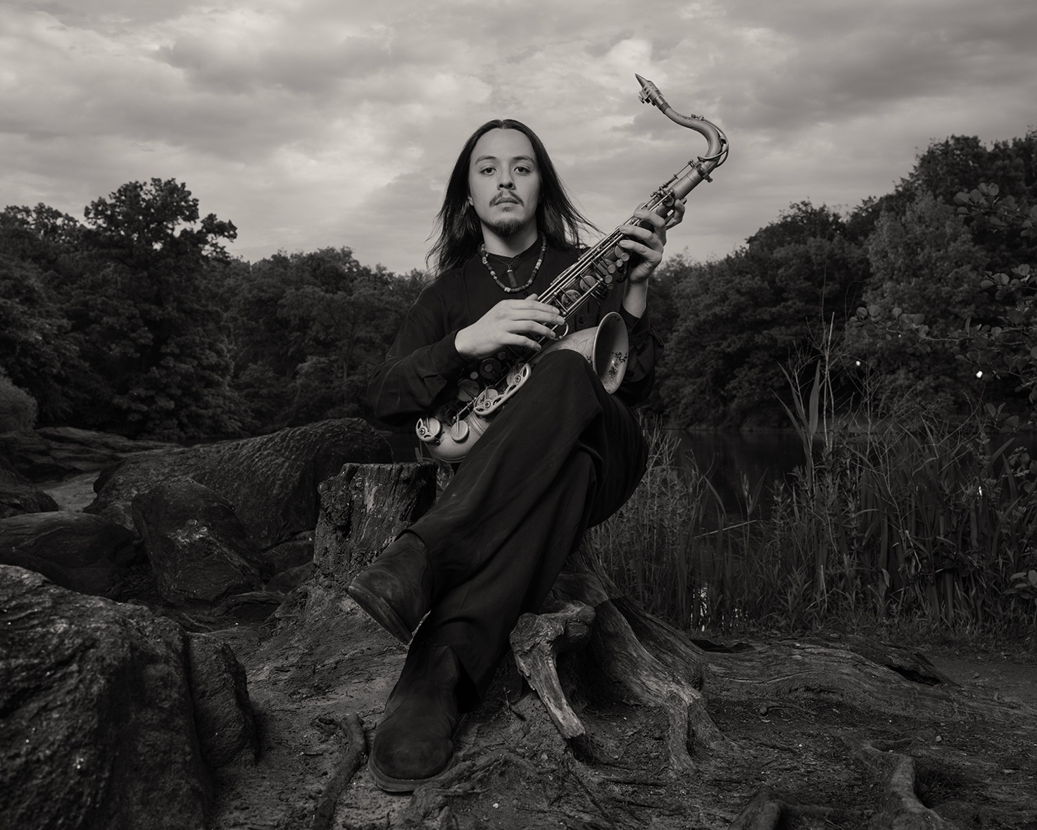

8)
Ben Solomon - Echolocation (by Ben Solomon “Echolocation”)
(Davis Whitfield, Rashaan Carter, Kush Abadey)
Recorded Live at Ornithology in Brooklyn by Jimmy Katz & James Kogan
Mixed & Mastered by Jimmy Katz with Dave Darlington
Photography Jimmy & Dena Katz with Carl Chisolm
https://bensolomon.bandcamp.com/album/echolocation

